***1-Topshiriq***

***3-variant***

***1.n butun son berilgan (n>0) .Quyidagi yig’indini hisoblovchi programma tuzilsin.***

***S=n^2+(n+1)^2+(n+2)^2+…+(2*n)^2***

***Dastur kodi:***

*n=int(input("n sonini kiriting (n>0):"))*

*s=0*

*for i in range (n,2*n+1):*

*s+=i**2*

*print("s soni=",s)*

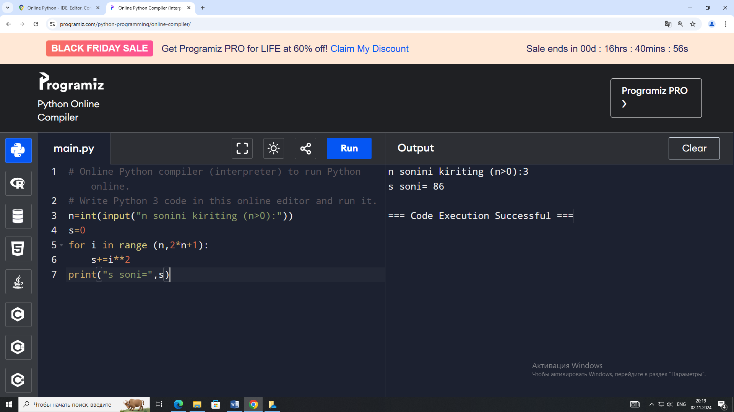

***2.Satr berilgan. Satrdagi kichik lotin va kirill harflarining umumiy sonini aniqlovchi programma tuzilsin.***

***Dastur kodi:***

*satr = input("Satrni kiriting: ")*

*kichik_harflar_soni = 0*

*for harf in satr:*

*if harf.islower():*

*kichik_harflar_soni += 1*

*print(f"Satrdagi kichik harflar soni: {kichik_harflar_soni}")*

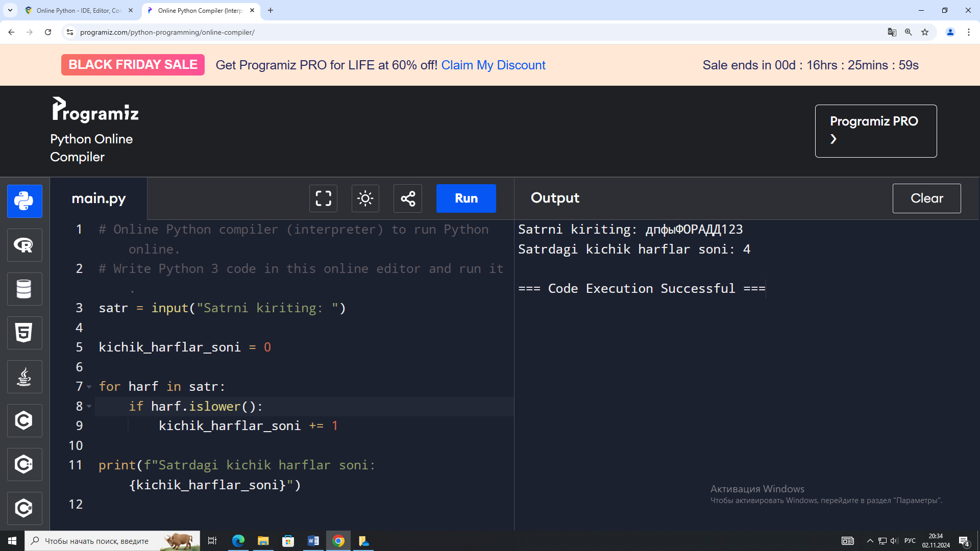

***3.Uch xonali son berilgan .Jumlani rostlikka tekshiring”Ushbu sonning barcha raqamlari xar xil”***

***Dastur kodi:***

*son = int(input("Uch xonali son kiriting: "))*

*a = son % 10*

*b = (son // 10) % 10*

*c = son // 100*

*if a != b and a != c and b != c:*

*print("Ushbu sonning barcha raqamlari xar xil.")*

*else:*

*print("Ushbu sonning barcha raqamlari xar xil emas.")*

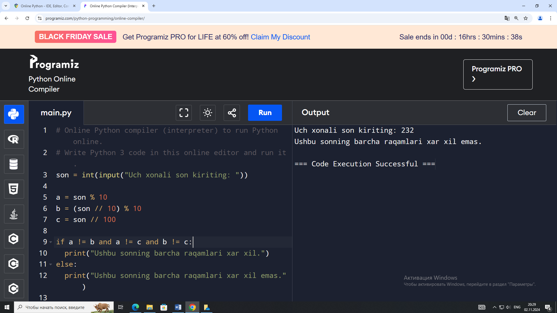

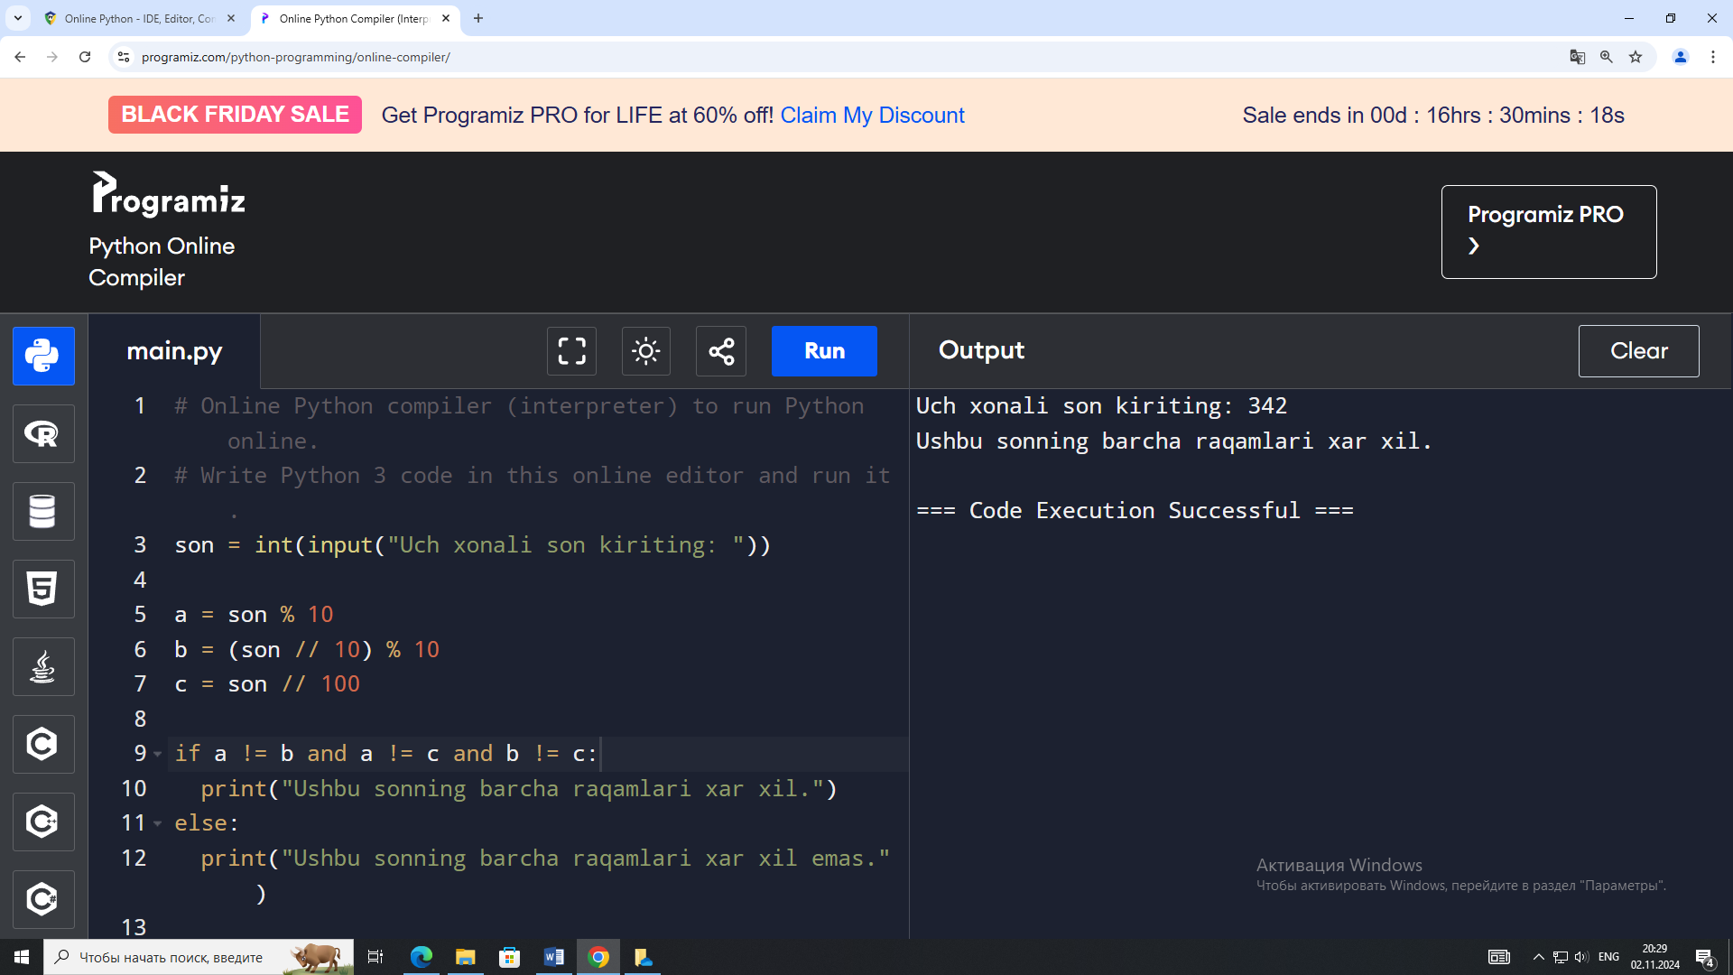

***RT-4/5-21 –guruh kursanti: Hasanov Sirojiddin Allaberdiyevich***